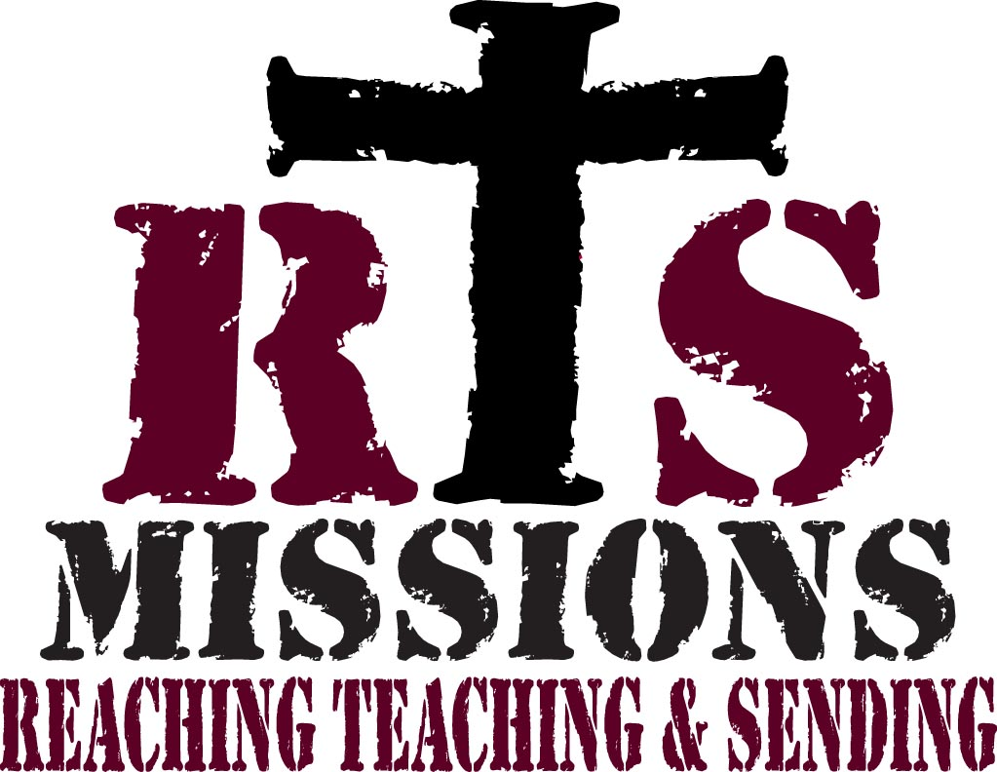

MISSION TEAM
ORIENTATION MANUAL

RTS Missions
PO Box 897
Land O Lakes, FL 34639
800-692-1410 toll
813-321-7809 voice
813-354-4625 fax

Table of Contents

What We Do 2

Map of Haiti 3
Profile / History 4

Explain Haiti 5

Travel Instructions 6

Guest House and Accommodations 8

Christians in Haiti 9
Travel and Security Issues 10
Money Issues & Shopping 10
Contacting Home 10

Preparing for, Working in, and Evaluating the Project 11

Evaluation 11

Creole Phrases 12

1
What We Do

RTS Missions is an all-inclusive missions sending organization. From the moment God places a trip in your heart, RTS will help you every step of the way to bring this trip to fruition and magnify His glory. Once a team has begun to form RTS will:

- Meet with members of the team and set up a series of future team meetings that will prepare them for the experience God has called them too.

- Schedule a full team orientation explaining every facet of the mission trip they will be part of. This includes cultural training so they are prepared as much as possible for the things they will see and experience.

- Handle the purchasing of missionary travel insurance.

- Register the team with the State Department

- Offer suggestions for team 40 Days of Devotion, or facilitate the devotion. This is an excellent way of preparing the teams heart for their trip.

- Lead the team through the entire mission trip

- Hold an exit debriefing the night before we fly out. This is very important as these missionaries will have seen things they have never imagined and will need time to talk about it before coming back to the states.

2
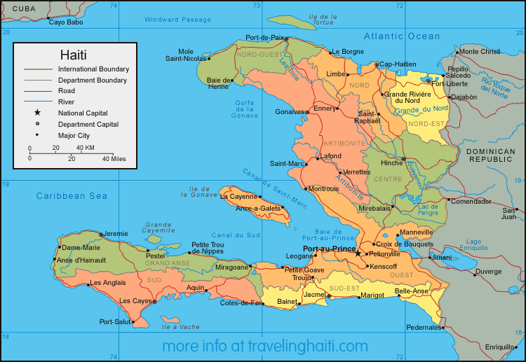

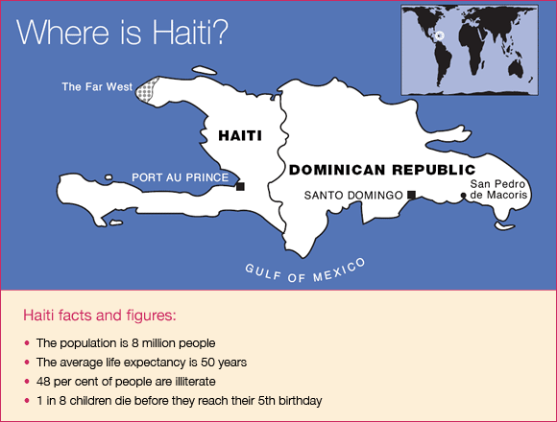

3
Profile / History

People

Nationality: Haitian
Population: 7.65 million (lower than expected due to AIDS)
Ethnic Groups: African American descent 95%; African and European descent 5%
Languages: French and Creole
Education: Literacy 53%
Health: Life Expectancy 52 (50.5 male & 53 female)

Geography

Capital City: Port-Au-Prince (population 2.75 million estimated)
Area: 27,750 square kilometers (10,714 square miles); about the size of Maryland
Terrain: Mountainous; rest is plain
Climate: Warm, semiarid; high humidity in many coastal areas

Government

Type: Judicial – Supreme Court, Extremely unstable
Independence: 1804
Constitution: 1987
Branches: Executive – President; Legislative – Senate (27 seats) l Assembly of Deputies
- seats); Judicial - Court of Cassation
Administrative Subdivisions: Nin Departments
Political Parties: Numerous

Economy

Poorest country in Western Hemisphere
80% live in abject poverty
2/3 depend on agriculture (small scale subsistence farming)
Inflation Rate 38%
Agriculture Products: coffee, mangoes, sugarcane, rice, corn, sorghum, wood
Industries: sugar refining, flour milling, textiles, cement, light assembly industries based on imported parts
Average Annual Income: $300 (less than a dollar a day)

Taken from CIA – world fact book website; last update 12/16/2004

4

Taken From Written In Blood, The story of the Haitian People, 1942-1995

How does one explain Haiti? What is Haiti? Haiti is the eldest daughter of France and Africa. It is the place of beauty, romance, mystery, kindness, humor, selfishness, betrayal, cruelty, bloodshed, hunger, and poverty.

For nearly two centuries the real Haiti has been obscured by distance, prejudice, illusion, misunderstanding, and accumulated misinformation. Much that is obscured is neither beautiful nor romantic. Crookedness and selfishness are everywhere; so are faithfulness, revenge, and misery.

Haiti is the second free nation of the Western Hemisphere and the world’s first black republic. Yet in 1991 – almost two centuries’ freedom notwithstanding, Haiti remained more underdeveloped than much of Africa from which it emerged. Haiti is not merely the poorest country in the hemisphere but one of the poorest anywhere. In 2002 her annual per capita income amounted to $270. Haiti is also one of the few countries in the latter twentieth century whose gross national product has stagnated or declined more years than it has advanced.

Only 13% of Haiti’s 7 million acres are worth cultivating. Four fifths of the people (to whom the plow remains unknown) till their plots with hoes, machetes, or sharp sticks. The whole of Haiti, acre by acre, bursts with an average of 500 persons per square mile, going above 1000 feet where the land is good – a density unequalled save in Java or the Nile Valley. This teeming population often lives in relative isolation from its own cities and towns and even neighbors. Interior regions of Haiti are very inaccessible. Peasants can live their without seeing the main towns. Citizens of Port-au-Prince know little of Haiti’s back country. Most villages of the interior can be reached only on foot, by donkey, or, under the most favorable conditions, by Jeep.

Haiti speaks two languages. French, the official administrative tongue is understood by 15% of
the people. Creole, a blend of the seventeenth-century provincial French and West Africa dialects, is Haiti’s true national language and sole tongue of 85% of the population.
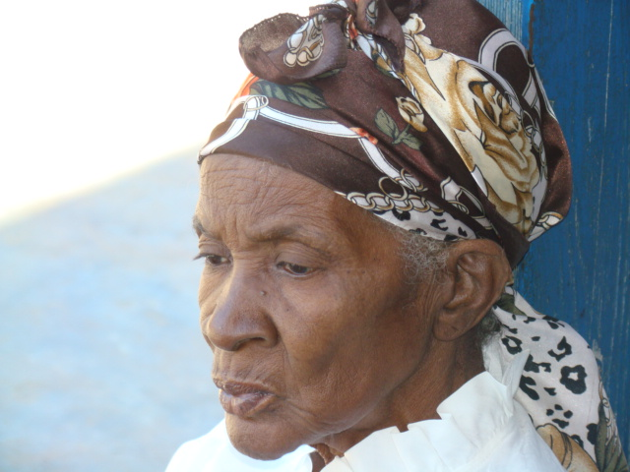

It is an old saying that Haiti is 80% Catholic and 100% Voodoo. This may not be the literal truth, but it is doubtful whether more than 15% of Haiti – including a small but vigorous Protestant community – practices Christianity exclusively.

Voodoo has sunk its roots deep into Haitian soil. Voodoo plays so central a role in the life and history of Haiti that to disregard it (as Americans did during their occupation) is to foreclose serious understanding of its people.

5
Travel Instructions to and from Haiti
Volunteer Teams

Before you leave:

- You will need to get a current passport. Check with local officials in locations you can get the paperwork at a post office and in other places you will find it in the “Clerk of Courts” office. Please very immediately that your passport does not expire at least 6 months after your scheduled return home.

- You will need certain shots and medications:

  - Tetanus needs to be updated
  - Typhoid
  - Hepatitis A
  - Hepatitis B for medical project participation
  - Anti-malarial medication – Follow the medication instructions completely. Do Not Miss Any Doses. NOTE: Some medications require taking at least 2 weeks prior to your departure. (Your family physician should be able to write the prescription)

(The shots can be obtained at your local health department. The medication prescription can be obtained from the Health Department and filled at your local pharmacy.)

- When packing for Haiti, keep these things in mind:

  - It is hot. Pack light-colored clothes. Women should avoid knit clothing, padded garments, and bring extra undergarments and socks. Be prepared to sweat.
  - The sun is bright. Bring sunglasses, sun block, and a hat.
  - You will be on your feet. Bring comfortable shoes.
  - You will be expected to dress nicely for church, especially if you have a part in the worship service. The Haitian people wear there very best at church.
  - You will have to carry your luggage to and from the airport and to the project site; pack lightly and plan to mix and match shirts/slacks to save space. Be sure to pack all toiletries, since shopping is not a real option. Women need to pay special attention to their personal items and be sure they have an adequate supply.

- Arrive at the airport no less than two hours before departure. Your luggage will receive rough treatment, and will probably become soiled in the process.

6
As you are flying:

- On the plane from the United States to Port-au-Prince, you will be asked to fill out a form for International Travel. You will need this form as you enter the country.
- You will also be asked to fill out a Customs form. Both forms will be handed to the customs agent when you land. On the form, you will be asked to write the full address of your destination. The address is:

This information will be given to you before the team leaves.

When you arrive in Haiti: (Your RTS Missions leader will take you through this process)

- Basically follow the crowd. You will enter the terminal and proceed through immigrations. You will need your passport, the paperwork you completed on the airplane, and your luggage claim ticket readily available. You will need $10 for a tourist tax.

- You will hand you passport and the International Travel form to the designated person. You will receive back a green tab and your passport. HANG ON TO THE GREEN TAB. This is your exit VISA that will be needed as you leave the country.

- You will then move to the luggage area to claim your luggage. As soon as you get to the luggage area, get needed carts ($2US each), and wait for your luggage. Do not receive help unless you are willing to pay even when they show you an “official” badge. The badge simply lets them inside. Then proceed to the Customs area; smile and hand them the customs form. After that you will exit the building. At some point someone will check and take your luggage claim ticket. Members of our team will meet you at baggage claim and bring you the rest of the way.

- As you exit the building area, there is usually a large crowd and some confusion as people beg for money and grab the bags. (They are not trying to steal, but are wanting to carry the bags to the car in exchange for money). Be sure to have about $2 per cart in one dollar bills. RTS will have people on the ground that will help with bags.

- Work your way through the crowd as quickly as possible and get into your waiting cars. You will be greeted by individuals working with RTS. Once in the car, you are home free. Do not go with anyone who says, “I know the pastor. Come with me.” WAIT!!! WELCOME TO HAITI!

7

When you return home:

- During the debriefing led by your RTS Missions Coordinator, he will “walk” you through the exit procedure and will be guiding you through the process.
- Plan to arrive at the airport 3 hours before departure.
- As you pull up, men (baggage handlers) will try and carry your bags into the airport. Just say “no merci” which means “no thank you.”
- Move to the appropriate airlines counter. The line is usually long, so be willing to wait.
- After you have your boarding pass, you will proceed to the left of the check-in area as you enter the immigration area. There will be an airport tax checkpoint where the green receipt is taken. Proceed to an immigration line. Have your passport, the green VISA copy and boarding pass out. Your passport will be stamped and the green VISA copy will be received. As you enter the waiting area, you may go upstairs where there are a few shops and food.

Accommodations

RTS Missions utilizes two main guest resorts. Please do not let the word resort paint a picture that of staying in a modern hotel in the states. Although, our accommodations will not be what you are used to, they are very nice considering we are in a third world country.

Keep these things in mind:

- It is not the Holiday Inn. You do have a comfortable bed to sleep in, and after a day in Haiti you would sleep anywhere.

- Water is sometimes hard to come by. If we do have water there it is a high percentage that it will be cold water only. Plan on a couple cold showers.

- Electricity is not dependable. Although rooms do have electricity, it will not be available until the evening time.

Bring some wash cloths and one or two light personal towels.

8

Food

In most cases, great care is taken in food preparation. While in Haiti, you must always know where your food comes from. Don’t buy any food items off the street. While in the Guest House, all meals will be prepared by the staff cooks. Always drink the bottled water supplied to you by the RTS Missions team. There will be plenty of water and drinks for the team to stay hydrated.

Christians in Haiti

The people of Haiti are very proud of there heritage. This is true of Christians in Haiti also. The heritage is not very long, but is very strong.

The Christian Haiti Church is different from the churches in the United States.

- Buildings – None of the churches look the same. Many look like regular buildings from the outside. They may lack electricity, furniture or even windows.

- Worship – Haitian Christians are very expressive in their worship. You will find excitement in their music and preaching. The services are sometimes several hours long. They hold services on different days of the week, and start very early on Sunday.

- Dress – Haitian Christians always dress in their best for worship services.

9

Travel and Security Issues

Travel

The roads in Haiti are rough at best. Driving a vehicle in Haiti is not for the faint of heart. Travel is slow and difficult. Many travel memories will be made.

When transporting larger groups, there is a possibility that a bus may be rented. Most often we use vans and pick up trucks.

Security Issues

As of this time, we have never had a problem with any type of violence or crime. We tend to be more proactive in this area. We provide security for traveling and while at the Guest House. Follow all directions of the RTS Missions Coordinator; the security; and the Haitian leadership. No one should ever wander off alone.

Money Issues and Shopping

Money in Haiti is gourdes but spends as Haitian dollars. There is no actual Haitian dollar, but five gourdes always equals one Haitian dollar. The exchange rate is variable, but US dollars have a good return.

There is very little chance for you to spend money during the week. All of your in-country expenses are taken care of before you arrive.

Your RTS Missions coordinator will provide an opportunity to exchange some money for you to take home.

Contacting Home

RTS Missions will have a phone which has the capabilities to call the states on every trip.

Internet service is not reliable and access to a computer is very difficult. RTS Missions will always try and send updates from the team to family and friends if possible.

10

Preparing for, Working in, and Evaluating the Project

- Learn some French / Creole phrases. “Please” (sil vous plait) and “thank you” (merci) are a great way to bridge the language barrier.

- Build a prayer team. Begin to pray early for the project, the people of Haiti, and your team members. Being prayed up is important.

- Plan several meetings / training sessions with the group before you leave. Everyone will need to know what they will be doing before you get to Haiti. (If possible)

- Always remain flexible, “Blessed are the flexible for they will not get bent out of shape.” See things as opportunities, not obstacles.

- Plan daily personal and group morning devotionals. At day’s end, plan to have “decompressing” time to assimilate the days activities and plan the next day.

- Make sure all your flights are planned. Make sure RTS Missions knows your flight itinerary as soon as you book your flights.

- All in-country expenses need to be paid in advance. Please refer to your Trip Sheet for important deadlines.

- BE A TEAM. Each team member should have a job assignment, i.e. devotion leader, team photographer, logistics manager, and while others are teaching and preaching, etc., PRAY.

- Have your church commission you as a missionary. A commissioning service could be done in the morning or evening worship service, and will be very meaningful for you and your church.

Evaluation

- Take plenty of slides, pictures, video, and souvenirs for display.

- Celebrate your trip. Set a time during your worship service to celebrate you mission trip. Let the group give testimonies about their experiences.

- RTS will conduct a debriefing on your last night in Haiti.

11

Creole Phrases Everyone Needs

English Creole

I (don’t) have money Mwen (pa) genyen kob
I (don’t ) want that Mwen (pa) vie sa
I need food (also, I need to eat) Mwen bezwen manje
I am thirsty Mwen swaf
My name is __________ Mwen rele _________
How are you? Koman ou ye? / Kijan ou ye?
I am well Mwen byen
Where’s the toilet? Kote twalet la?
If God wills (wants) it Si Die vie
God is good Bondye bon
God is love Bondye se lanmou
God bless you Bondye beni ou
No problem Pagen Pwoblem
Jesus loves you Jesu renmen ou
Lord Segne
Living Water D’lo fwe
Bible Bib
Christ Krist
Grace Gras

12

